
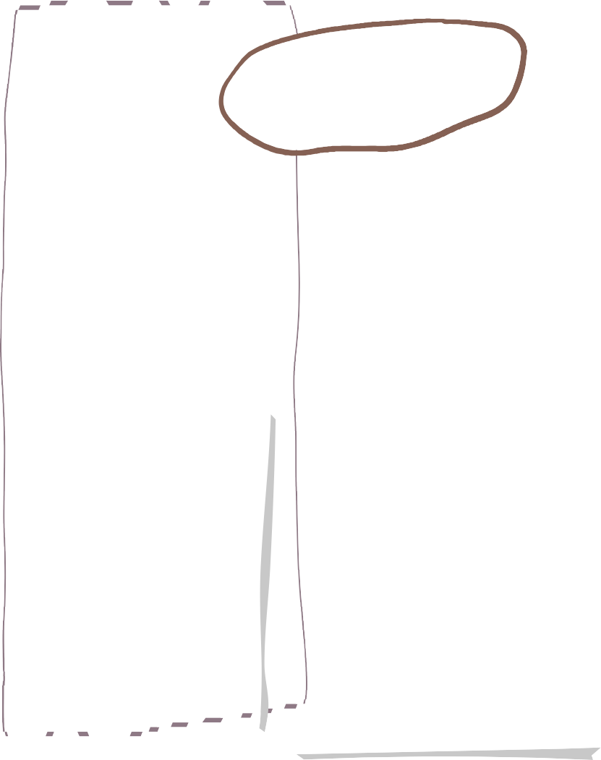


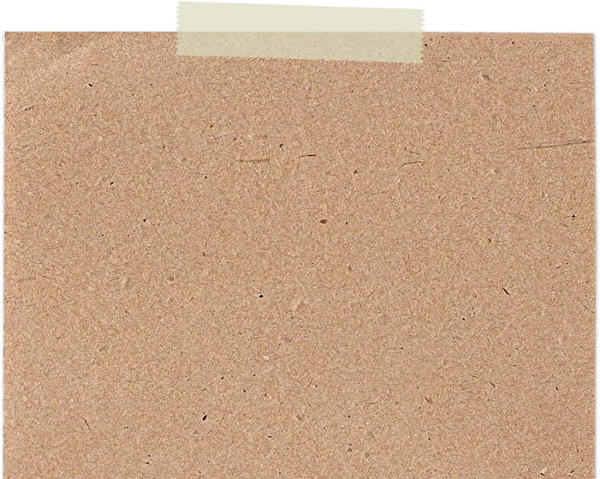

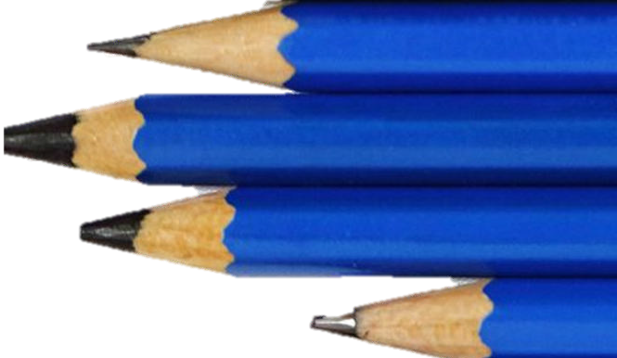
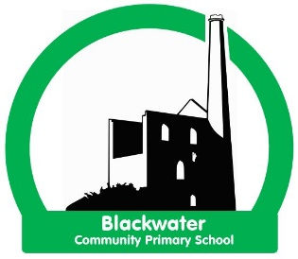
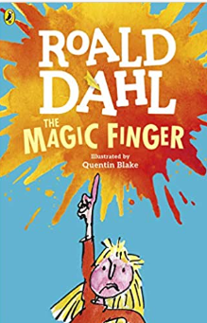
-Blend sounds into words, so that they can read short words made up of known letter-sound correspondences.
-Develop storylines in their pretend play and use talk to help work out problems and organise thinking and activities.
-Develop the foundations of a handwriting style by using a tripod grip to form lower-case and capital letters correctly.
-Join in with repeated refrains and anticipate key events and phrases in rhymes and stories.
-Use talk to support the writing process.
-Use writing to communicate thoughts, ideas, experiences and events.
-Articulate their ideas and thoughts in
well-formed sentences and describe
events
using some detail.
-Ask a relevant scientific question to find
out more, explain how things work and why they might happen.
-Develop storylines in their pretend play and use talk to help work out problems and organise thinking and activities.
-During small group or one to one discussions, ask questions to find out more and understand what has been said to them.
-Listen to and talk about selected non-fiction books to develop a deep familiarity with new knowledge and vocabulary.
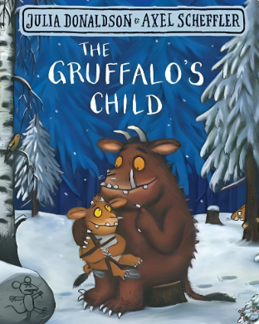
We are learning about Winter Wonderland
Driver area of learning- Understanding the World

This project teaches children about the changes that happen during winter, including the types of weather associated with winter. It also explores places that have snow all year round and the types of animals that live there.

We are reading…

Wheal Friendly Reception- Spring Term 1 2025
Literacy
Communication and language
Project
Physical Development

-Choose and explore appropriate tools for simple practical tasks.
-Create art in different ways on a theme, to express their ideas and feelings.
-Develop the foundations of a handwriting style by using a tripod grip to form lower-case and capital letters correctly.
-Manipulate malleable materials into a variety of shapes and forms using their hands and other simple tools.
-Move energetically and repeatedly, with improved fluency, control and grace when dancing and moving in time to music.

-Continue, copy and create repeating patterns using a variety of objects.
-Explore addition and subtraction with numbers to 10, using concrete objects, pictorial representations and number lines.
-Follow instructions, including simple recipes, that include measures and ingredients.
-Identify and represent up to five objects, without counting, using concrete objects and pictorial representation.
-Recall number bonds to 5 and explore the different ways that groups of 6–10 objects can be represented.

Mathematical development

*Listen to others when one to one or in a small group, and start and continue a conversation with a friend.
-Describe how the weather, plants and animals of one place is different to another using simple geographical terms
-Describe simply how weather changes as the seasons change.
-Describe some ways that plants or animals should be cared for in order for them to survive.
-Represent scientific observations by mark making, drawing or creating simple charts and tables.
-Offer explanations for why things happen, making use of vocabulary, such as, because, then and next.
-Use age-appropriate software to create images and record sounds and videos.
Understanding the World
Expressive Arts and Design
Personal, Social & Emotional Development







* Be increasingly independent in meeting their own care needs, including dressing themselves, brushing teeth, using the toilet, washing and drying their hands and using a knife and fork.
-Construct simple structures and models using a range of materials.
-Create art in different ways on a theme, to express their ideas and feelings.
-Create collaboratively, share ideas and use a variety of resources to make products inspired by existing products, stories or their own ideas, interests or experiences.
-Listen to a variety of music, rhymes and songs, paying attention to how they sound and sharing their opinions.
-Manipulate malleable materials into a variety of shapes and forms using their hands and other simple tools.
-Play cooperatively with others and take turns.

-Listen carefully in a range of situations and is aware of the importance of listening.

-To explore the natural world around them.

-Describe what they see hear and feel when outside.
*Comparing places and environments

*Season- Winter

*Cold habitats
Alfie’s weather
Penguin Small
The Snow Queen
Non-fiction books about cold places
The Gruffalo’s child
The big freeze
Snow bear
Kipper’s snowy day
Possible mini themes
Key texts
Outdoor learning

