Science Year Planner – Year 3 and 4 2022 2023
Term | Autumn 1 | Autumn 2 | Spring 1 | Spring 2 | Summer 1 and 2
Topic | Plants  (Year 3) | Animals Including Humans  (Year 4) | Rocks  (Year 3) | Forces and Magnets  (Year 3) | States of Matter  (Year 4)
Termly Project  : | Tribal Tales |  | Rocks, Relics and Rumbles |  | Misty Mountains, Winding Rivers
Science discipline: | Biology | Biology | Chemistry | Physics | Physics
Science Knowledge NC Focus: | - identify and describe the functions of different parts of flowering plants: roots, stem/trunk, leaves and flowers  - explore the requirements of plants for life and growth (air, light, water, nutrients from soil, and room to grow) and how they vary from plant to plant  - investigate the way in which water is transported within plants  - explore the part that flowers play in the life cycle of flowering plants, including pollination, seed formation and seed dispersal | - describe the simple functions of the basic parts of the digestive system in humans  - identify the different types of teeth in humans and their simple functions  - construct and interpret a variety of food chains, identifying producers, predators and prey | - compare and group together different kinds of rocks on the basis of their appearance and simple physical properties  - describe in simple terms how fossils are formed when things that have lived are trapped within rock  - recognise that soils are made from rocks and organic matter | - compare how things move on different surfaces  - notice that some forces need contact between 2 objects, but magnetic forces can act at a distance  - observe how magnets attract or repel each other and attract some materials and not others  - compare and group together a variety of everyday materials on the basis of whether they are attracted to a magnet, and identify some magnetic materials  - describe magnets as having 2 poles  - predict whether 2 magnets will attract or repel each other, depending on which poles are facing | - compare and group materials together, according to whether they are solids, liquids or gases  - observe that some materials change state when they are heated or cooled, and measure or research the temperature at which this happens in degrees Celsius (°C)  - identify the part played by evaporation and condensation in the water cycle and associate the rate of evaporation with temperature
Assessment for Learning and Enquiry Book | 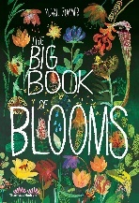 | 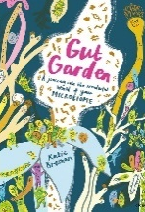 | 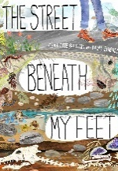 | 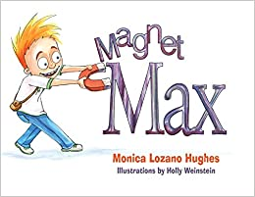 | 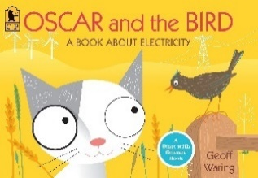
Sequence of learning: | Sequence of learning:  1. I can reflect on prior knowledge and ask scientific questions.  2. I can name the basic parts of a flower.  3. I can investigate what plants need to grow well.  4. I can observe how water is transported in plants.  5. I can explain pollination and fertilisation.  6. I can order the stages in a lifecycle of a plant. | Sequence of learning:  1. I can reflect on prior knowledge and ask scientific questions.  2. I can identify and name the parts of the human digestive system.  3. I can explain the functions of the digestive system.  4. I can identify the types of teeth and their functions.  5. I can create a model of teeth to investigate their functions. I can appropriately record my results.  6. I can construct and interpret a range of food chains. | Sequence of learning:  1. I can reflect on prior knowledge and ask scientific questions.  2. I can make compare and group rocks based on their physical appearance.  3. I can make systematic and careful observations by examining different types of rocks.  4. I can explain that fossils are formed when things that have lived are trapped within rock.  5. I can research Mary Anning’s contribution to palaeontology.  6. I can recognise that soils are made from rocks and organic matter. I can examine soil. | Sequence of learning:  1. I can reflect on prior knowledge and ask scientific questions.  2. I can identify forces. I can compare how a toy car moves on different surfaces.  3. I can describe magnets as having two poles. I can predict whether two magnets will attract or repel.  4. I can test whether materials are magnetic or non-magnetic.  5. I can investigate and compare the strength of different magnets.  6. I can use magnetism to create a compass to hunt from treasure. | Sequence of learning:  1. I can reflect on prior knowledge and ask scientific questions.  2. I can explain ways that electricity is generated. I can name common appliances that run on electricity.  3. I can construct a simple electrical circuit. I can name the basic parts.  4. I can identify whether or not a lamp will light.  5. I can recognise that a switch opens and closes a circuit.  6. I can recognise common conductors and insulators.
End Point: | Children will learn the relationship between structure and function: the idea that every part has a job to do; explore questions that focus on the role of the roots and stem in nutrition and support; leaves for nutrition and flowers for reproduction. | Children will learn the main body parts associated with the digestive system; explore questions that help children to understand their special functions. | Children can explore different kinds of rocks and soils , including those in the local environment. | Children can observe that magnetic forces can act without direct contact; explore the behaviour and everyday uses of different magnets | Children can explore a variety of everyday materials and develop simple descriptions of the states of matter; observe water as a solid, a liquid and a gas; note the changes to water when it is heated or cooled.
Vocabulary: | Vocabulary throughout:  Extinct, flower, fruit, nectar, ovary, ovule, petal, pollen, seed, stigma, style, stamen | Vocabulary throughout:  Canines, incisors, large intestine, molars, oesophagus, premolars, rectum, small intestine, stomach, tongue | Vocabulary throughout:  Arthropod, humus, igneous rock, metamorphic rock, sedimentary rock, palaeontologist, weathering | Vocabulary throughout:  Force, friction, magnetic material, non-magnetic material, North Pole, South Pole, sliding friction, static friction | Vocabulary throughout:  Atom, battery, cell, circuit, component, current electricity, negative terminal, positive terminal, static electricity, voltage

