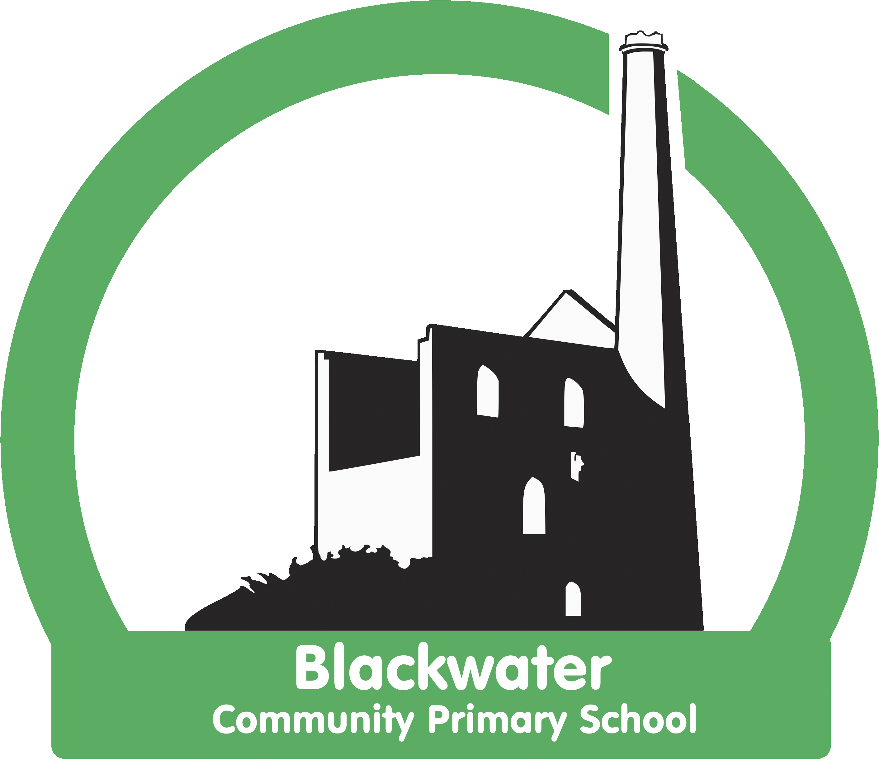

***Blackwater DT Strategy***

***2023 - 2024***

|  |
| --- |
| ***Statement of Intent*** |

*At Blackwater we believe that design and technology is at the centre of developing innovation, creativity and critical thinking. After all, humans have been designing and making since the earliest of times. Our very survival as a species depended on it! We endeavour to deliver a high-quality inspiring, rigorous and practical design and technology curriculum encouraging our children to create, innovate to design and make products that solve real and relevant problems within a variety of contexts. We aim to develop a sense of citizenship within local and global contexts by encouraging our children to consider their own and others’ needs, wants and values and questioning how to balance that with a more sustainable way of living. We aim for our children to acquire a broad range of subject knowledge and draw on disciplines such as mathematics, science, engineering, computing and art. Pupils learn how to take risks, becoming resourceful, innovative, enterprising and capable citizens. Through the evaluation of past and present design and technology, they will develop a critical understanding of its impact on daily life and the wider world. It is our hope our high-quality design and technology curriculum at Blackwater will make an essential contribution to the creativity, culture, wealth and well-being for our children in the future.*

***Learning to do****:*

*Generating ideas: The skills in designing and generating ideas*

*Making: The skills of making in design and technology including technical knowledge.*

*Evaluating: The skills of judgement and evaluation*

***Learning about:***

*Knowledge: knowledge about the technical process and work of designers past and present.*

|  |
| --- |
| ***Statement of Implementation*** |

*Children are taught through a sequence of lessons linked to their topic, working through the design, make, evaluate process. They engage in learning to:*

* *develop the creative, technical and practical expertise needed to perform everyday tasks confidently and to participate successfully in an increasingly technological world*
* *build and apply a repertoire of knowledge, understanding and skills in order to design and make high-quality prototypes and products for a wide range of users*
* *critique, evaluate and test their ideas and products and the work of others*
* *understand and apply the principles of nutrition and learn how to cook.*

*Our process looks like this:*

|  |  |  |  |
| --- | --- | --- | --- |
| *Design* | *Make* | *Final Product* | *Evaluate* |
| *Research, analyse and evaluate existing design.*  *This may include looking at key designers and design movements as well as analysing materials.*    *Generate, develop and communicate ideas in a variety of ways.*        *Develop criteria for their own design.* | *Select tools, materials and techniques best suited to the agreed design criteria.*    *Use and explore creative, technical and practical skills in the ‘making process’.* | *Bring all of this learning together to create a*  *‘final product’.* | *Evaluate the prototype against agreed criteria.*    *Celebrate:*    *Creativity*  *Technical knowledge*  *Practical skill* |

*In EYFS DT is a powerful vehicle for exploration, investigations through play. Children’s investigative and problem-solving skills are stimulated, nurtured and developed through high quality continuous provision and small group teaching. The children will engage spontaneously within a range of contexts using a variety of materials, exploring techniques and progressing skills through play and exploration as well as working on specific techniques through small group work. Their learning journey is documented through Tapestry.*

*In KS1*

*The children:*

***Design***

* *design purposeful, functional, appealing products for themselves and other users based on design criteria*
* *generate, develop, model and communicate their ideas through talking, drawing, templates, mock-ups and, where appropriate, information and communication technology*

***Make***

* *select from and use a range of tools and equipment to perform practical tasks [for example, cutting, shaping, joining and finishing]*
* *select from and use a wide range of materials and components, including construction materials, textiles and ingredients, according to their characteristics*

***Evaluate***

* *explore and evaluate a range of existing products*
* *evaluate their ideas and products against design criteria*

***Technical knowledge***

* *build structures, exploring how they can be made stronger, stiffer and more stable*
* *explore and use mechanisms [for example, levers, sliders, wheels and axles], in their products.*

*In KS2*

***Design***

* *use research and develop design criteria to inform the design of innovative, functional, appealing products that are fit for purpose, aimed at particular individuals or groups*
* *generate, develop, model and communicate their ideas through discussion, annotated sketches, cross-sectional and exploded diagrams, prototypes, pattern pieces and computer-aided design*

***Make***

* *select from and use a wider range of tools and equipment to perform practical tasks [for example, cutting, shaping, joining and finishing], accurately*
* *select from and use a wider range of materials and components, including construction materials, textiles and ingredients, according to their functional properties and aesthetic qualities*

***Evaluate***

* *investigate and analyse a range of existing products*
* *evaluate their ideas and products against their own design criteria and consider the views of others to improve their work*
* *understand how key events and individuals in design and technology have helped shape the world*

***Technical knowledge***

* *apply their understanding of how to strengthen, stiffen and reinforce more complex structures*
* *understand and use mechanical systems in their products [for example, gears, pulleys, cams, levers and linkages]*
* *understand and use electrical systems in their products [for example, series circuits incorporating switches, bulbs, buzzers and motors]*
* *apply their understanding of computing to program, monitor and control their products.*

*Children across KS1 and KS2 are taught through a two year rolling programme. Each term the children undertake a design project working through the Design, Make, Evaluate cycle building on technical knowledge and skills. The two year rolling programme provides a spiral curriculum, revisiting and embedding the progression of skills. Appendix 1 details how these skills progress from KS1 into KS2.*

***Assessment***

*Children are assessed in terms of their skills and knowledge each term.*

*Progress criteria are detailed in Appendix 1.*

***Food Technology***

*In EYFS food preparation during daily snack time is an integral part of the day and offers opportunity for discussion of healthy eating, the origins of food and exploration of taste and texture. Continuous provision and topic work enhances children’s understanding of the importance of food for health as well as engaging children in investigative and creative activities.*

*In KS1 children engage in food preparation termly, with a focus on healthy eating as well as the origin and sustainability of food production. Each term, children in KS2 learn a variety of techniques in the preparation of predominantly savoury foods. They also learn about the origins of food and food production. Nutrition is an important element in in food technology with children learning about food groups and the need for balance in a healthy diet.*

|  |
| --- |
| ***Statement of Impact*** |

*Our DT curriculum harbours the creativity, innovation of our children, engaging them in collaborative, problem solving tasks that develop their practical skills as well as being a relevant context for the discussion of wider global issues of sustainability complementing our work as an eco-school.*

*Children develop their skills through a spiral curriculum enabling them to revisit and practise skills in a variety of contexts thus deepening their understanding of the design process as well as their technical knowledge and skills.*

*Children develop a good understanding of food, its origins as well as an understanding of its nutritional value and the need for a balanced diet. They learn about hygiene and practical techniques in food preparation which equip them with important life skills.*

*The subject leader monitors the learning and teaching of design and technology across the school termly looking at work in class as well as pupil voice. She feeds back findings to staff and the effectiveness of DT delivery is discussed and monitored.*