Science Year Planner – Year 5 and 6 2021 -2022
Term | Autumn 1 and 2 | Autumn 2 | Spring 1 | Spring 2 | Summer 1 and 2
Topic | Electricity  (Year 6) | Earth and Space  (Year 5) | Living things and their habitats  (Year 5) | Animals including humans  (Year 5) | Properties of materials  (Year 5)
Termly Project | Fallen Fields |  | Allotment |  | Hola Mexico
Science discipline: | Physics | Physics | Biology | Biology | Chemistry
Science Knowledge NC Focus: | - associate the brightness of a lamp or the volume of a buzzer with the number and voltage of cells used in the circuit  - compare and give reasons for variations in how components function, including the brightness of bulbs, the loudness of buzzers and the on/off position of switches  - use recognised symbols when representing a simple circuit in a diagram | - describe the movement of the Earth and other planets relative to the sun in the solar system  - describe the movement of the moon relative to the Earth  - describe the sun, Earth and moon as approximately spherical bodies  - use the idea of the Earth’s rotation to explain day and night and the apparent movement of the sun across the sky | - describe the differences in the life cycles of a mammal, an amphibian, an insect and a bird  - describe the life process of reproduction in some plants and animals | - describe the changes as humans develop to old age | - compare and group together everyday materials on the basis of their properties, including their hardness, solubility, transparency, conductivity (electrical and thermal), and response to magnets  - know that some materials will dissolve in liquid to form a solution, and describe how to recover a substance from a solution  - use knowledge of solids, liquids and gases to decide how mixtures might be separated, including through filtering, sieving and evaporating  - give reasons, based on evidence from comparative and fair tests, for the particular uses of everyday materials, including metals, wood and plastic  - demonstrate that dissolving, mixing and changes of state are reversible changes  - explain that some changes result in the formation of new materials, and that this kind of change is not usually reversible, including changes associated with burning and the action of acid on bicarbonate of soda
Assessment for Learning and Enquiry Book | 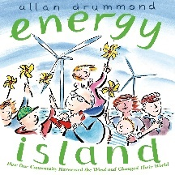 | 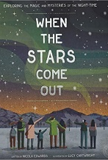 | 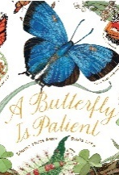 | 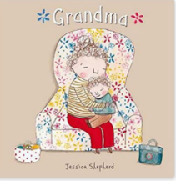 | 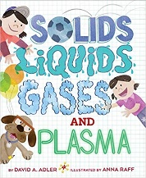
Sequence of learning: | Sequence of learning:  1. I can reflect on prior knowledge and ask scientific questions.  2. I can explain the importance of electricity.  3. I can research uses for electricity.  4. I can construct an electrical circuit.  5. I can associate the brightness of a light or volume of a buzzer with the number of volts used in a circuit.  6. I can use recognised symbols when drawing a representation of a simple circuit. | Sequence of learning:  1. I can reflect on prior knowledge and ask scientific questions.  2. I can name and describe the planets. I can discuss the movement of the planets relative to the Sun.  3. I can describe the movement of the Moon relative to the Earth.  4. I can create models of the Sun, Earth and Moon to represent the solar system. I can explain rotation.  5. I can explain day and night and the apparent movement of the sun across the sky.  6. I can research and compare the time of day at different places on the Earth. | Sequence of learning:  1. I can reflect on prior knowledge and ask scientific questions.  2. I can classify animals based on whether they are a mammal, amphibian, insect, bird or fish.  3. I can describe the differences in the life cycles of animals.  4. I can research the work of naturalist David Attenborough.  5. I can describe the life process of reproduction in some plants.  6. I can describe the life process of reproduction in some animals. | Sequence of learning:  1. I can reflect on prior knowledge and ask scientific questions.  2. I can describe the stages of human development and draw a timeline.  3. I can explain how babies grow and develop in their first year.  4. I can describe the changes that happen during puberty between boys and girls.  5. I can identify the changes that happen in old age.  6. I can record complex data using graphs to compare gestation periods and life expectance of animals. | Sequence of learning:  1. I can reflect on prior knowledge and ask scientific questions.  2. I can compare materials according to their properties including hardness, conductivity, transparency and response to magnets.  I know that some materials will dissolve in liquid to form a solution.  I can explore how mixtures can be separated through filtering, sieving and evaporating.  5. I can demonstrate that dissolving, mixing and changes of state are reversible changes.  6. I can explore irreversible changes.
End Point: | Children can build on prior knowledge, construct simple series circuits to answer questions about what happens when they try different components; represent a simple circuit in a diagram using recognised symbols. | Children will understand the model of the sun and Earth to explain day and night; learn that the sun is a star at the centre of our solar system and that it has 8 planets; understand that a moon is a celestial body that orbits a planet. | Children can Observe life-cycle changes in a variety of living things: plants/animals in the local environment; the work of naturalists and animal behaviourists: David Attenborough and Jane Goodall. | Children can understand the Stages in the growth and development of humans; the changes experienced in puberty; gestation periods of other animals and comparing them with humans. | Children will be able to explore and compare the properties of a broad range of materials; explore reversible changes, including evaporating, filtering, sieving, melting and dissolving.
Vocabulary: | Vocabulary throughout:  Electron, series circuit, parallel circuit, resistance | Vocabulary throughout:  Axis, constellation, eclipse, galaxy, moon, orbit, planet, star, universe | Vocabulary throughout:  Anther, cell. embryo, fertilisation, life cycle, life span, ovary, ovule. womb | Vocabulary throughout:  Anomalous result, brain, gestation period, hormone, nerves, organ, puberty | Vocabulary throughout:  Atom, dissolve, filter, insoluble, irreversible change, melt, particle, reversible change, soluble, solution

