
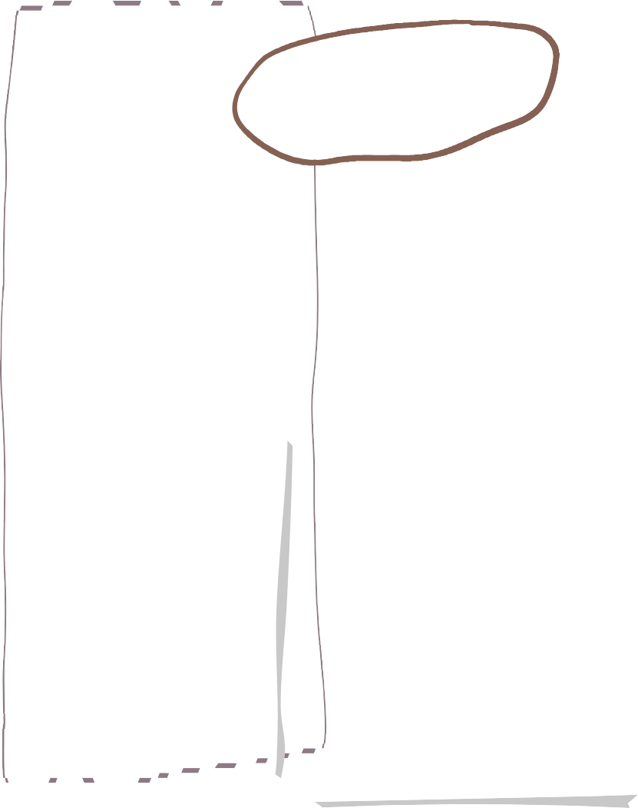


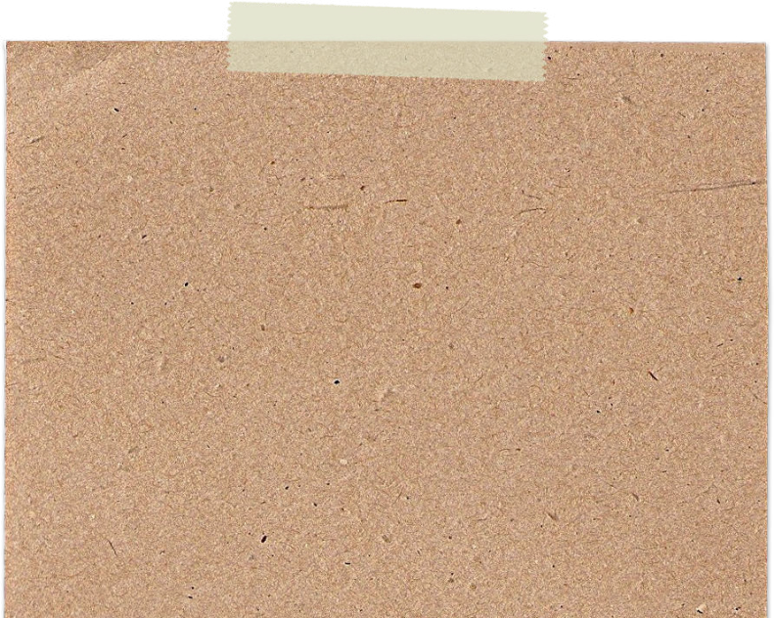

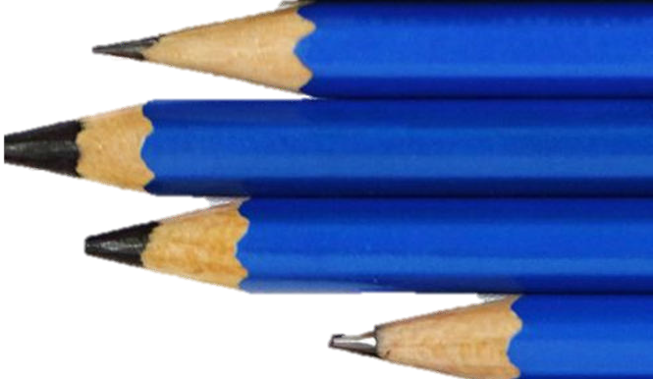
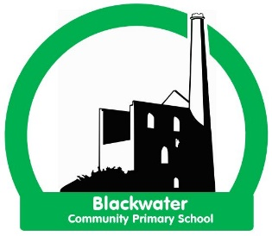
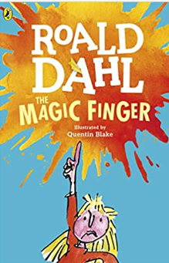
We are learning about Marvellous Me!
Driver area of learning- Understanding the World

Key questions

What makes me special - how am I unique?
What am I good at?
Our families
How has my body changed?
Names of key body parts.
How do we use our senses?

-Children begin to listen to other children in their setting
-Listen during story time and show an interest in the books being read.
-Children sit on the carpet and show some attention. -Children can pay attention to one thing at a time.
-Children follow simple 1 step instructions.
-Children understand appropriate ‘why’ questions.
-Children speak in simple sentences.
- Children can say simple rhymes and sing songs and poems.
-Children speak to the adults and children in the class, they talk to other children during their play.

-Children joining in with rhyme, songs and poems.
-Children are encouraged to hold a book correctly and carefully turn pages.
-Children understand books have a beginning and an end.
-Children listen and enjoy sharing a range of books both fiction and non-fiction.
-Children know that text in English is read top to bottom and left to right.
-Children can recognise pictures and illustrations in a text Vs the writing.
-Children can discriminate sounds (Phase 1 Phonics) such as instruments and cars.
-Children are beginning to be able to orally blend and segment.
-Writes their name - copying it from a name card or trying to write it from memory.
-Develop an awareness that writing communicates meaning.
-Gives meaning to marks they make.

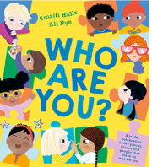
We are reading…

Wheal Friendly Reception- Autumn Term 1 2025
Literacy
Communication and language
Project
-To match and sort objects and pictures
-To understand and make pairs
-To understand rules and to sort objects following rules
-To compare amounts
-To compare size, mass, capacity
-To explore and create patterns

Physical Development

-Begin to use their core muscle strength to achieve good posture when sitting on the floor or at the table.
-Begin to safely use tools and equipment.
-Children use pencils and other equipment comfortably for them.
-Children make snips in paper either using one hand or two.

Mathematical development






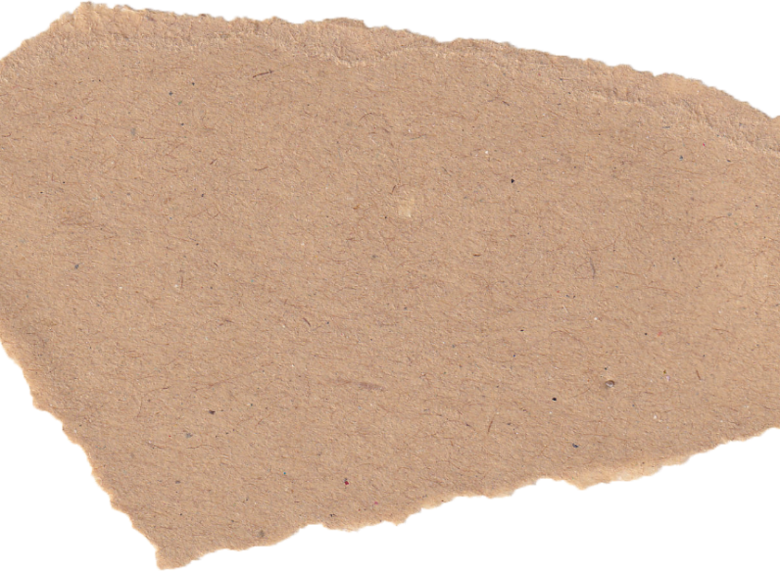
*Listen to others when one to one or in a small group, and start and continue a conversation with a friend.
-Children talk about their feelings to trusted adults or special friends.
-Children may come into school upset but can be comforted by adults.
-Children listen to the rules and expectations and begin to follow them.
-Children are developing an awareness of themselves and are forming their own opinions.
-Children are beginning to learn the classroom rules and are following these with some reminders.
-Children are becoming more independent at coming into school in the morning and getting ready for home at home time.
-Use the toilet independently most of the time at school.
-Know that it is okay to ask for help and will do so.
-Children build new positive relationships with pupils and staff in the setting.
-They may begin to play alongside unfamiliar children if ready.

-Begin to talk about my life story and how I have change
-Guess baby pictures – how I have grown
-Look at similarities and differences between the natural world around me in the past and present
Understanding the World
Expressive Arts and Design
Personal, Social & Emotional Development

* Be increasingly independent in meeting their own care needs, including dressing themselves, brushing teeth, using the toilet, washing and drying their hands and using a knife and fork.
-Safely use and explore a variety of materials, tools and techniques, experimenting with colour, design, texture, form and function
-Follow drawings and curved and straight lines to create line drawings of different buildings
-Detailed self-portraits using a choice of materials
-Know a range of songs related to myself and my community
-Sing in a group or on my own, following the melody and increasingly matching the pitch
-Copy-clap the rhythm of names--Explore high sounds and low sounds using voices
-Begin to move in response to music
-Begin to use observation skills to draw things with increasing details

Home learning project
Letter formation (lowercase) using Little Wandle mnemonics covering;
S,A,T,P,I,N,M,D,G,O,C,
K,CK,E,U,R,H,B,F,L

From Week 4 of the programme:
Spelling CVC words daily i.e. cat, dog, cup

Little Wandle phonics
Create a self-portrait using any media you choose! Get creative!

Due in on Friday 10th October 2025
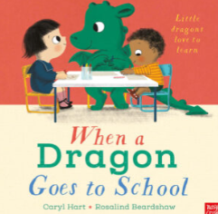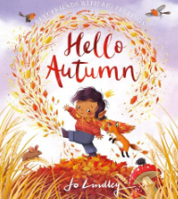

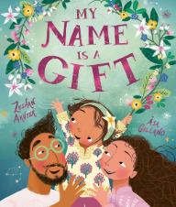
Key texts

