Science Year Planner – Year 3 and 4 2021 2022
Term | Autumn 1 and 2 | Spring 1 | Spring 2 | Summer 1 | Summer 2
Topic | Animals Including Humans  (Year 3) | Living Things and Their Habitats  (Year 4) | Light  (Year 3) | Sound  (Year 4) | Electricity  (Year 4)
Termly Project | I am Warrior | Blue Abyss |  | Traders and Raiders
Science discipline: | Biology | Biology | Physics | Physics | Physics
Science Knowledge NC Focus: | - identify that animals, including humans, need the right types and amount of nutrition, and that they cannot make their own food; they get nutrition from what they eat  - identify that humans and some other animals have skeletons and muscles for support, protection and movement | - recognise that living things can be grouped in a variety of ways  - explore and use classification keys to help group, identify and name a variety of living things in their local and wider environment  - recognise that environments can change and that this can sometimes pose dangers to living things | - recognise that they need light in order to see things and that dark is the absence of light  - notice that light is reflected from surfaces  - recognise that light from the sun can be dangerous and that there are ways to protect their eyes  - recognise that shadows are formed when the light from a light source is blocked by an opaque object  - find patterns in the way that the size of shadows change | - identify how sounds are made, associating some of them with something vibrating  - recognise that vibrations from sounds travel through a medium to the ear  - find patterns between the pitch of a sound and features of the object that produced it  - find patterns between the volume of a sound and the strength of the vibrations that produced it  - recognise that sounds get fainter as the distance from the sound source increases | - identify common appliances that run on electricity  - construct a simple series electrical circuit, identifying and naming its basic parts, including cells, wires, bulbs, switches and buzzers  - identify whether or not a lamp will light in a simple series circuit, based on whether or not the lamp is part of a complete loop with a battery  - recognise that a switch opens and closes a circuit and associate this with whether or not a lamp lights in a simple series circuit  - recognise some common conductors and insulators, and associate metals with being good conductors
Assessment for Learning and Enquiry Book | 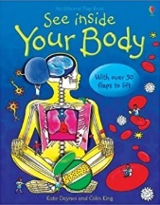 | 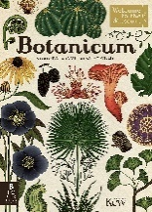 | 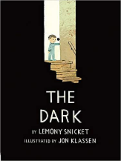 | 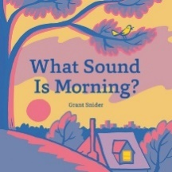 | 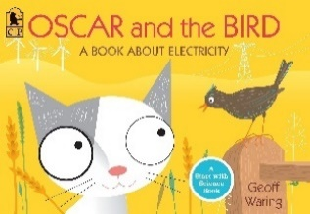
Sequence of learning: | Sequence of learning:  1. I can reflect on prior knowledge and ask scientific questions.  2. I can explain that humans get their nutrition from what they eat.  3. I can explain the importance of diet and exercise.  4. I can sort animals by investigating their skeleton types.  5. I can explain the importance of bones for support, protection and movement.  6. I can explain the importance of muscles for support, protection and movement. | Sequence of learning:  1. I can reflect on prior knowledge and ask scientific questions.  2. I can group living things in a variety of ways.  3. I can use classification keys to group, identify and name a variety of living things.  4. I can recognise positive and negative changes to the local environment.  5. I can research the danger that changing environments could have on animals.  6. I can design a habitat.  I can use scientific evidence to answer questions and support my findings. | Sequence of learning:  1. I can reflect on prior knowledge and ask scientific questions.  2. I can recognise that I need light to see things and that dark is the absence of light.  I can notice that light is reflected from surfaces.  4. I can recognise that light from the sun can be dangerous and that there are ways to protect my eyes.  I can recognise that shadows are formed when the light from a light source is blocked by an opaque object.  6. I can find patterns in the way that the size of shadows change. | Sequence of learning:  1. I can reflect on prior knowledge and ask scientific questions.  2. I can identify how sounds are made and associate them with something that vibrates.  3. I can recognise that vibrations from sound travel through a medium to the ear.  4. I can measure the vibrations produced by instruments and find patterns between volume and vibrations.  5. I can explore ways to change the pitch of sound by creating an instrument with high and low sounds.  6. I can recognise that sounds get fainter as the distance from the source increases. | Sequence of learning:  1. I can reflect on prior knowledge and ask scientific questions.  2. I can explain ways that electricity is generated. I can name common appliances that run on electricity.  3. I can construct a simple electrical circuit. I can name the basic parts.  4. I can identify whether or not a lamp will light.  5. I can recognise that a switch opens and closes a circuit.  6. I can recognise common conductors and insulators.
End Point: | Children to understand the importance of nutrition; introduction to the main body parts associated with the skeleton and muscles; finding out how different parts of the body have special functions. | Children can identify and study plants and animals in their habitat; identify how the habitat changes throughout the year; grouping a wide selection of living things that include animals, flowering plants and non-flowering plants. | Children can explore what happens when light reflects off a mirror or other reflective surfaces; shadows, how they are formed and what might cause the shadows to change. | Children can and identify the way sound is made through vibration in a range of different musical instruments from around the world; and find out how the pitch and volume of sounds can be changed in a variety of ways. | Children can create simple series circuits, trying different components, for example, bulbs, buzzers and motors, and including switches, and use their circuits to create simple devices. Children should draw the circuit as a pictorial representation,
Vocabulary: | Vocabulary throughout:  Balanced diet, carbohydrates, carnivore, fats, herbivore, invertebrate, minerals, omnivore, protein, unbalanced diet, vertebrates, vitamins | Vocabulary throughout:  Amphibians, birds, echinoderms, herbaceous flowering plants, invertebrates, mammals, molluscs, species, vertebrates | Vocabulary throughout:  Image, light beam, light ray, mirror, reflected ray, reflection | Vocabulary throughout:  Frequency, pitch, sound wave, vibration, volume | Vocabulary throughout:  Atom, battery, cell, circuit, component, current electricity, negative terminal, positive terminal, static electricity, voltage

