
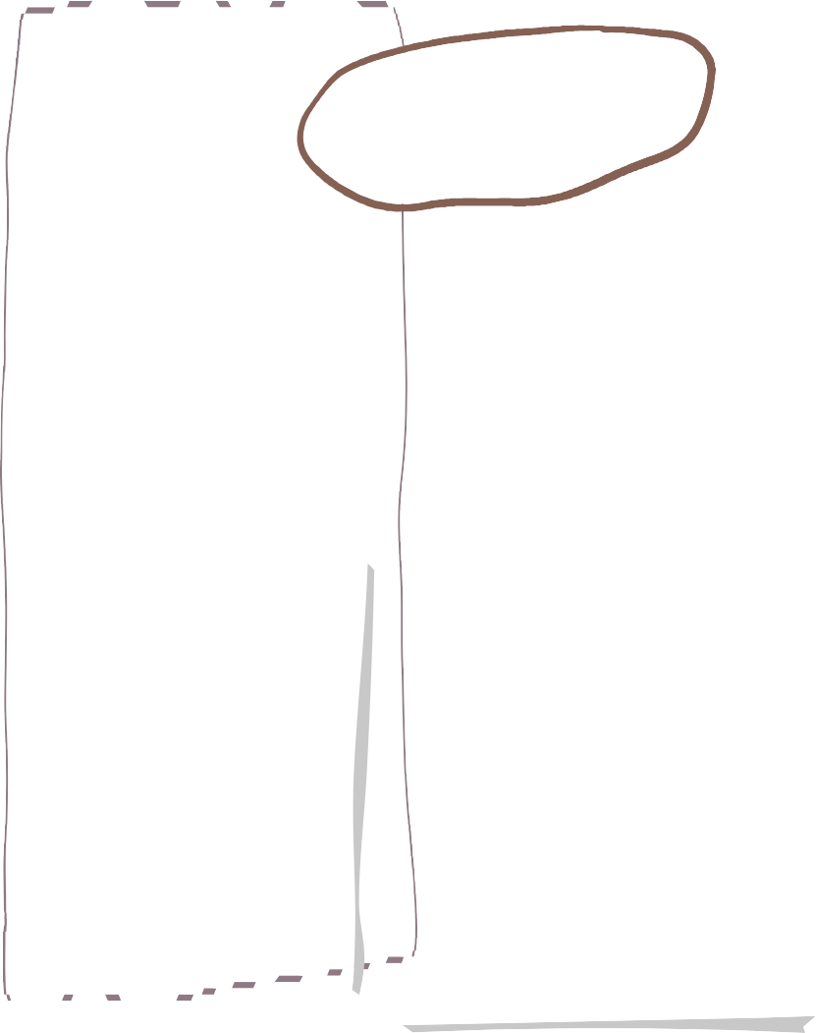






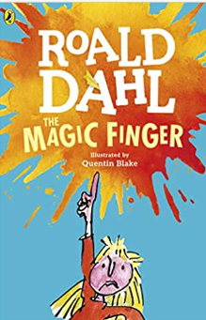
-Begin to join in with familiar rhymes and stories.
-Sing some parts or certain Nursery Rhymes.
-Learns new vocabulary from stories, rhymes, poems and non-fiction books.
-Have a favourite book and seeks it /them out to share with an adult or look at alone.
-Hear different environmental sounds around me.
-Begin to recognise some environmental print such as supermarket logos.
-Develop an interest in making marks.
-Begin to distinguish between marks and pictures/drawings.

-Beginning to listen to stories and nursery rhymes.
-Beginning to listen to instructions given. -Listens during adult guided activities.
-Focusing on an activity of my own choice for a short period of time. -Beginning to show attention to the adults in my setting.
-Recognises and points to objects that are spoken to me.
-Links words together when speaking.
-Develop more speech sounds and pronunciation of sounds.
-Use words to begin to communicate my needs.

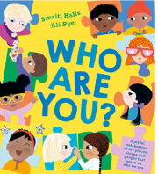

We are learning about Marvellous Me
Driver area of learning- Understanding the World

Key questions
Who are we?
What do we look like?
Do we look the same?
What is my body?
Names of simple body parts.
Where do we live?
Who can help me?
What are senses?

We are reading…

Wheal Friendly Nursery- Autumn Term 1 2025
Literacy
Communication and language
Project
Physical Development

-Walk and crawl confidently.
-Climb using two feet at a time.
-Know how to scoop and pour e.g. sand, mud.
-Run around the setting with some control and direction.
-Clap and stamp to music.
-Children use a palm grip when using mark making tools.
-Children use a spoon to feed themselves correctly.
-Children use spring loaded scissors to make snips into paper with adult support.

-Recognise, name and match colours.
-Begin to show an interest in counting aloud verbally to 5.
-To be able to ‘give 1’ when asked.

Mathematical development

*Listen to others when one to one or in a small group, and start and continue a conversation with a friend.
Understanding the World
Expressive Arts and Design
Personal, Social & Emotional Development







* Be increasingly independent in meeting their own care needs, including dressing themselves, brushing teeth, using the toilet, washing and drying their hands and using a knife and fork.
-Express when they feel happy, sad, tired or upset.
-Learn about emotions through stories and discussions.
-Take turns with other children with adult support.
-Explore the classroom with adult support.
-Use the toilet with adult support.
-Take turns with other children with support from the adults in my setting.
-Separate from my parent/ caregiver with adult support.

-Recognises colours and chooses them for a purpose.
-Uses thick paint brushes.
-Uses playdough to roll, cut, ball, sausage.
-Builds towers with large construction equipment.
-Children dancing to music.
-Children exploring moving to music in different ways
-Children show an interest in the small world and roleplay areas, children role playing their first-hand experiences.

-Children use words ‘now’ and ‘next’.
-Children talk about their family, who they live with and any pets.
-Children talk about their families.
-Children talk about who is special to them and why.
-Children name their family members.

We will learn how to be safe in the wild area and how to care for the environment.
Home learning project
Create a self-portrait using any media you choose! Get creative!

Due in on Friday 10th October 2025

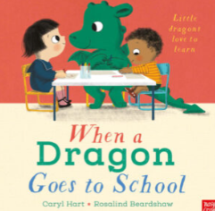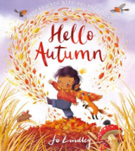

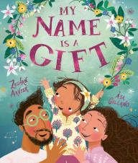
Key texts
Outdoor learning

